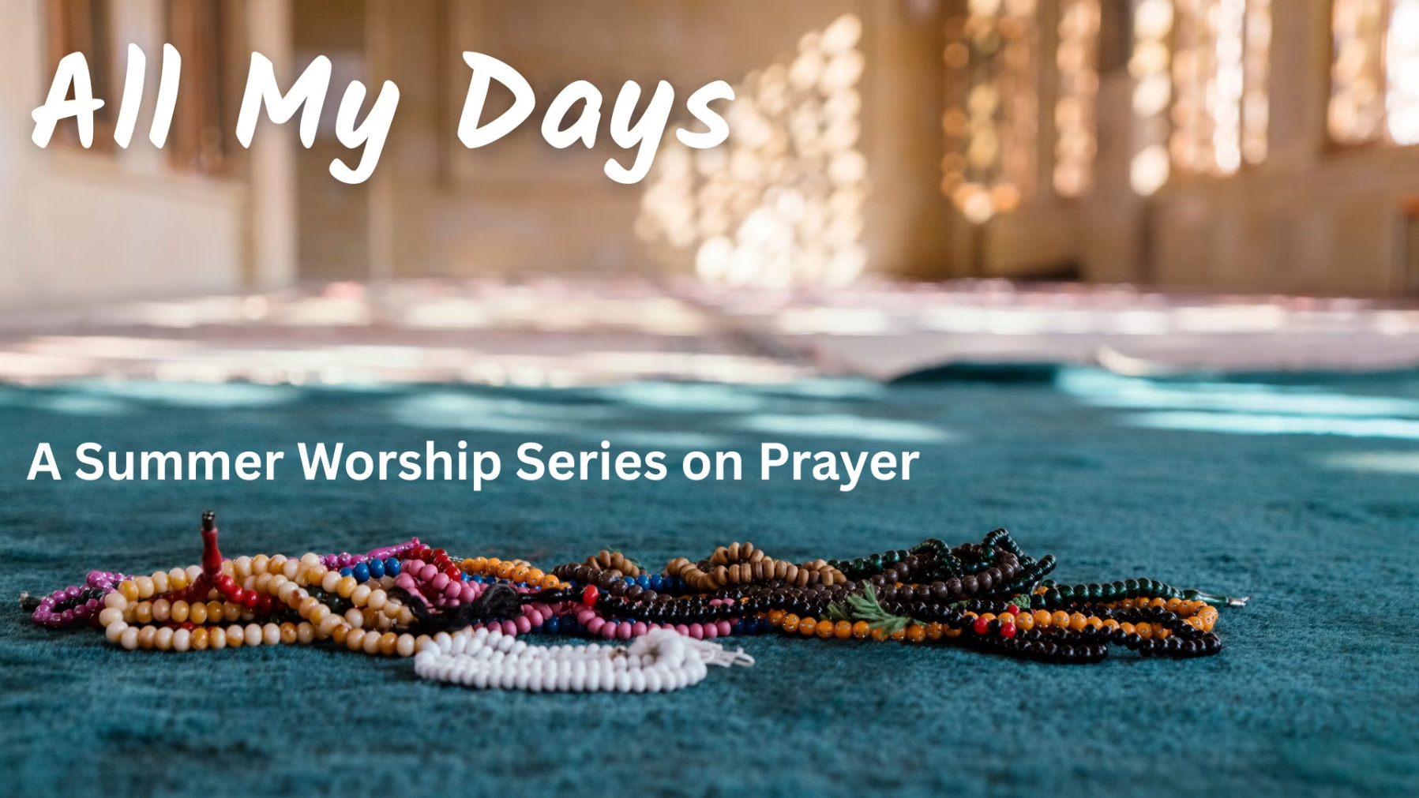

Pardon
August 9, 2026

We are a progressive community of faith seeking to follow
the teachings of Jesus, pursue justice and live God’s love.

No matter who you are, or where you are on life’s journey,

you are welcome here.


A Note for Families / Folks of All Ages: During the summer, we do not have church school, but young people are encouraged to check the basket at the back of the sanctuary, or the table in the narthex for activities. There are clipboards with paper and coloring pages, for worshippers of any age to use during the service.

PRELUDE Take Time to Be Holy George C. Stebbins
Arr. Lloyd Larson

WELCOME TO WORSHIP

THRESHOLD MOMENT

*CALL TO WORSHIP
One: We arrive fully into this moment, Holy One.
We open to sense your presence among us.
We hear you say,
ALL: “Grace is always embracing you.”
One: We need you, Jesus, to help us.
We come to you as your first disciples did.
We hear you say,
ALL: “Grace is always embracing you”
One: Spirit of Divine Love,
come to us with your healing waters.
We hear you say,
ALL: “Grace is always embracing you.”

*OPENING HYMN Diverse in Culture, Nation, Race No. 372
____________________________________________
*Please rise, on your feet or in your hearts.
PRAYER FOR FORGIVENESS
When we are hurt or offended and we fail to forgive, forgive us!
When we cling to our anger, or to thoughts of blame, forgive us!
When it seems easier to hold a grudge or to point a finger in accusation, than it does to take a deep breath and to forgive…
expand our minds and our hearts, and give us the courage
to see the healing power of forgiveness. Amen

PRAYERFUL PAUSE

WORDS OF ASSURANCE

PASSING OF THE PEACE One: The peace of Christ be with you.
All: And also with you.

*SUNG RESPONSE Peace Like a River African American Spiritual ▤
I’ve got peace like a river, I’ve got peace like a river,
I’ve got peace like a river in my soul. (Repeat)

I’ve got joy like a fountain…
I’ve got love like an ocean…

SACRED PLAY

PRAYER FOR ILLUMINATION Rod Wendt
One: This is the story of God’s journey with God’s people - including all of us.
All: Open our hearts to receive and our lives to be expanded by what we hear.

SCRIPTURE Colossians 3: 12-14 & Mark 11:25

SERMON “Set it Down” Rev. Steve Savage

MOMENT OF CONTEMPLATIVE SILENCE

ANTHEM Etude Op. 10 No. 3 “Tristesse” Frederic Chopin

PRAYERS OF THE PEOPLE

THE LORD’S PRAYER
Our Father-Mother in heaven, hallowed be Your name. Your kin-dom come; Your will be done on earth as it is in heaven. Give us this day our daily bread and forgive us our debts as we forgive our debtors. And lead us not into temptation but deliver us from evil, for Yours is the kin-dom and the power and the glory forever. Amen.

SUNG RESPONSE Open My Eyes Manibusan/Zaragoza
Open my eyes, Love, Help me to see your face.
Open my eyes, Love. Help me to see.
Open my ears, Love. Help me to hear your voice.
Open my ears, Love. Help me to hear.
Open my heart, Love. Help me to love like you.
Open my heart, Love. Help me to love.
I live within you. Deep in your heart, O Love.
I live within you. Rest now in me.
OFFERING INVITATION

Help us to live God’s love and justice. You can make a secure gift by scanning the QR code, by going to fccucc.org and clicking on “Donate,” or by adding your contribution to the box at the back of the sanctuary.

MUSICAL INTERLUDE

BLESSING OUR GIFTS

*CLOSING HYMN Help Us Accept Each Other No. 376

ANNOUNCEMENTS

BENEDICTION

POSTLUDE I Am Loved William J. Gaither, arr. Fred Bock

* * * * *

WORSHIP NOTES

Thank you to this morning’s ushers: Team D, Scott Berry, captain.
Livestream: Thank you to Alex Ratta for managing our worship livestream!

The flowers on the altar are given in Loving Memory of Jeff York and Bo Baker by Terry York and Judy Baker; Seth York and his wife Sarah Hughes and children Levi and Magnolia; William York and his wife Susan York and their son Oliver.

All My Days is adapted from the series created by Marcia McFee and the Worship Design Studio and used by permission. Worshipdesignstudio.com/days

▤ Royalty for Spirituals: Historically, the composers of African American Spirituals were neither known nor compensated for use of their songs. The FCCUCC music department has committed to paying forward a ‘royalty’ each time we include a Spiritual in worship. We donate funds to the Indigo Arts Alliance. Join us: you can donate by check or online, with “Royalty for Spirituals” in the memo. Thank you.
WEEKLY @ FCCUCC

Bible Study every Tuesday, 12:30 - 1:30 pm in Davidson Lounge: Explore the scripture from the past Sunday, led by Pastor Steve.

Prayer Shawls, every Wednesday, 1 - 3 pm, Summer location changes weekly: Text Lynne Lanctot at 318-1605 by Tuesday evening for location. New and experienced knitters welcome. Bring needles size 9, 10, or 11, and your own yarn, or check out the church yarn supply. Questions? Lynne: lanctotla74@gmail.com.

Meetinghouse Choir and Handbell Choir are on summer break. They will resume rehearsals at the end of August.

COMING UP @ FCCUCC

Handbell Basics Workshop, Thursday, August 13, 6:00 pm - 7:00 pm: Handbell Director Sharon Potter will be presenting a Handbell Basics Workshop in the Sanctuary. If you would like to learn how to ring handbells and play in the choir or are just curious about how the instrument works, this workshop is for you. Ages 11 and up are welcome and no prior experience or music reading ability is required. If you are interested or would like more information please contact Sharon Potter at handbells@fccucc.org.

Faith and Fiction - in Davidson Lounge following worship on Sunday 8/30 and 9/20: Join FCCUCC member Chuck Warner and Pastor Steve for reflection on various books and short stories. In August and September, we will be reading, Parable Of The Sower by Octavia Butler! Anyone interested is invited to gather to discuss the first 13 chapters on August 30, and the remainder of the book on September 20. The book is widely available, and often in stock at local libraries and local bookstores. Please contact Pastor Steve if you are having difficulty finding the book.

MISSION AND SOCIAL WITNESS

Children’s Clothes Closet is now open to the public!
- Second and fourth Wednesdays, 11 am - 1 pm
- Second and fourth Saturdays, 12 pm - 2 pm

If you are interested in volunteering, contact AnnElissa Leveque or Pastor Steve at steve@fccucc.org.

Clothing Donations:
- Clean, wearable children’s clothes of all sizes (including teens) can be dropped off on the 5th floor, in the Children’s Clothes Closet donation bin just inside the left-hand door.

- Adult clothes, shoes and accessories, both wearable and unwearable, can now be deposited in the Apparel Impact Bin in the main parking lot. Upcycle and recycle to keep clothes out of our landfills! Learn more: https://www.apparelimpact.com/.

Clynk Bags are in the narthex (inside main entrance). Collect your returnable cans and bottles and return them to a Clynk collection site at Hannaford or other participating grocery stores. Scan the code on the bags and the refunds will automatically be donated to our FCC mission team. Thank you!

Volunteer for Preble Street Food Hub: On the last Friday of each month, we prepare meals at the Food Hub, 75 Darling Avenue, South Portland, for delivery to Preble Street satellite sites. Please join us! To learn more about how to volunteer, see the Weekly Word or contact Danna Wiggins at dannawig2@gmail.com.

THE WIDER COMMUNITY

Multifaith Community Vigils, August 11, 18 and 25, 5:30-6:00 pm in Mechanics Park (corner of Main and Water Streets), Biddeford: Join one or more of these weekly vigils led by different local multifaith leaders in Biddeford/Saco (modeled after the vigils we held outside Cumberland County Jail), as together we offer support for grieving neighbors and build loving community. These are prayerful gatherings of love, solidarity and support for the Biddeford community, especially for Johan Sebastián Durán Guerrero’s family and friends, our immigrant neighbors, those feeling unsafe, and all caught up in systems of injustice and division.

SUMMER SCHEDULE

- Rev. Alison Buttrick Patton, Senior Pastor, will be away for vacation: Monday, August 3 - Monday, August 24.

* * * * * *

WHAT’S UP?

Want to stay in the loop? Make sure you are on our email list! To UPDATE or ADD your contact info, go to: fccucc.org and select “Contact Us”.
Find us, like and follow us on social media. Now on Substack! @FCCUCC





