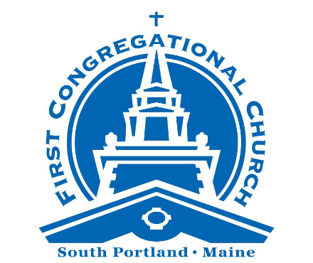

Sunday Worship
August 24, 2025

We are a progressive community of faith seeking to follow
the teachings of Jesus, pursue justice and live God’s love.

No matter who you are, or where you are on life’s journey,
you are welcome here.



A Note for Families / Folks of All Ages: We worship all together this morning. There are clipboards with paper and coloring pages at the back of the sanctuary, for worshippers of any age to use during the service.

PRELUDE How Great Thou Art Boberg and Hine
Walter Kimball, Bass
WELCOME TO WORSHIP Rev. Alison Buttrick Patton and Rev. Stephen Savage
*CALL TO WORSHIP
One: God, we come to You eager to go out into the world
All: Making God endorsed changes.
One: Teach us to be prophets for You.
All: To speak, to name, and to act as God's hope and freedom in this time.
One: Remembering always the faithfulness and ancient goodness of God.

*OPENING HYMN Here in This Place (Gather Us In) #250

PRAYER FOR FORGIVENESS*
ALL: Creator God, with each breath of life you breathe, you give gifts to your creation, calling us to use your gifts to build up your kingdom on earth. We confess that sometimes we do not see your gifts for the treasures they are. We either take credit for them ourselves, or we dismiss them as not important. We privilege some gifts over others, forgetting that you care about tiny things as much as big things. And when we are called upon to use our gifts for your glory, so often we find ourselves distracted by our own desire and uncertain of your direction. Forgive us. Open our ears to hear you speaking, and our hearts to embrace your purpose. Amen.

PRAYERFUL PAUSE

WORDS OF ASSURANCE

*PASSING OF THE PEACE
One: The peace of Christ be with you.
All: And also with you.

*SUNG RESPONSE Halle, Halle, Halle! Caribbean Traditional
Halle, halle, halle-lu-lu-jah! [3 times]
Hal-le-lu-jah, hal-le-lu-jah!
____________________________________________
*Please rise, on your feet or in your hearts.
PRAYER OF ILLUMINATION Judy Kimball
One: This is the sacred story of God’s journey with God’s people.
All: Holy One, open our ears to hear, our hearts to receive
and our lives to be expanded by your Word. Amen.

SCRIPTURE READING 1 Kings 21: 1-21a

SERMON “Have You Sold Yourself Lately?” Rev. Deborah Tomblyn

MOMENT OF CONTEMPLATIVE SILENCE

ANTHEM Will the Circle Be Unbroken? Habershon and Gabriel
Walter Kimball, Bass, Deirdre McClure, Guitar, Terry Foster, Piano

PASTORAL PRAYER

The Lord’s Prayer

Our Father-Mother in heaven, hallowed be Thy name. Thy kin-dom come; Thy will be done on earth as it is in heaven. Give us this day our daily bread and forgive us our debts as we forgive our debtors. And lead us not into temptation but deliver us from evil, for thine is the kin-dom and the power and the glory forever. Amen.

SUNG RESPONSE Hear Our Prayer, O God Whelpton
Hear our prayer, O God. Hear our prayer, O God.
Incline your ear to us and grant us your peace.

OFFERING INVITATION
Help us to live God’s love and justice. You can make a secure gift by using the QR code, going to fccucc.org/donate, or by adding your contribution to the box at the back of the sanctuary. Thank you!

CLOSING HYMN Go Forth for God #35

ANNOUNCEMENTS

BENEDICTION

POSTLUDE Leaning on the Everlasting Arms Martin

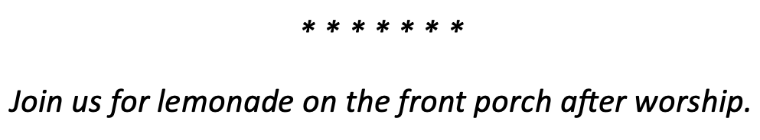
WORSHIP NOTES
Thank you to this morning’s ushers: Team H, Carrie Skeffington, captain.
The Mission Globe is lighted In Loving Memory of my Father John Payson, from Heather Payson and Family.
Livestream: Thank you to Alex Ratta for managing our worship livestream, this week and every week!
This morning’s Prayer for Forgiveness was written by the Rev. Teri Peterson, of the presbyterian church of Palatine, Il.

WEEKLY @ FCC UCC

Tuesday Bible Study meets from 12:30 - 1:30 pm in Davidson Lounge: whether you are a member of FCC UCC or you are simply interested in joining in the fun, you are invited to join our weekly bible study group, to enjoy fellowship and to discuss the worship and focal scripture from the past Sunday. All are welcome!
Meetinghouse Choir, Handbells and Handchimes are on summer recess. Rehearsals will resume on August 27.

WELCOME SUNDAY
Join us for a BBQ hosted by the Fellowship Club and the Education, Growth, and Fellowship Committee in the parking lot following our Homecoming Service on Sunday, September 7th. We are looking for contributions for hot dogs, hamburgers, and veggie burgers along with sides and other items.
Please click link in the Weekly Word to review the available slots and click the "Sign Up" button to select what you will contribute. Thank you and we look forward to seeing you on Homecoming Sunday!

BACKPACKS AND SUPPLIES
It's that time again to collect backpacks and supplies.There are donation boxes in the office and the narthex; please click the link in the Weekly Word to review the requested items and click the "Sign Up" button to select what you will contribute. Many thanks for continuing to support our local students!


FAIR TRADE COFFEE, TEA, AND SNACKS

What if food could be traded in a way that’s honest and fair? That’s the premise of the Equal Exchange Food Co-op, supporters of authentic fair trade since 1986. First Congregational Church is a reliable supporter of this program as a community and also through individual orders. The products are first rate and taste that much better knowing what your money is supporting! The new price list is out and we are taking orders. Please have orders to Judy Kimball by September 3. See the Weekly Word for price list and more information about the Equal Exchange Co-Op. Thank You for supporting fair trade!

MISSION CORNER

Volunteer for Preble Street Food Hub: On the last Friday of each month, we prepare meals at the Food Hub, 75 Darling Avenue, South Portland, for delivery to Preble Street satellite sites. Please join us! To learn more about how to volunteer, see the Weekly
Word or contact Danna Wiggins at dannawig2@gmail.com

Clynk Bags are available in the narthex (inside main entrance). Fill with returnable bottles and cans and return it to a Clynk collection site near Hannaford to support FCC!

BUILDING UPDATES!

Small Parking Lot: The small church parking lot adjoining Mitchell Road is currently being repaved, along with Mitchell Road itself.

THE WIDER COMMUNITY

Community Sing, TODAY, August 17, and every other Sunday, 3:30 pm (2:45pm for anyone looking to get organized around singing at demonstrations and public events): A bi-weekly gathering to find hope in singing together. Sign up to learn about future events or to opt-in to the Response Team to sing at resistance and change events:
- To register or ask questions, email Emilia Dahlin at: emilia@emiliadahlin.com

Ideal Maine Band, Tuesdays at 6 pm, Ocean Gateway: Sing along with the Ideal Maine Band during their weekly rehearsals. It's joyous and raucous! Come for the music, the camaraderie, and the community singing. And if you're up for it, get ready to sing at upcoming protests. https://www.idealmaineband.org/

A DAILY BLESSING: Need a spirit-lift? Sign up to receive a daily blessing in your inbox, each morning between now and September 15. Offered as part of the Bless Project at South Congregational Church, UCC, in Kennebunkport.

Sign up here:
https://www.southchurchucc.org/blessproject#daily-blessing

WHAT’S UP?

Want to stay in the loop? Make sure you are on our email list! To UPDATE or ADD your contact info, go to: fccucc.org and select “Contact Us” then select “Contact Info Update Form.”

Also, look for us on Facebook: facebook.com/fccucc
on Instagram: instagram.com/fccucc_s.portland
and on our YouTube channel: youtube.com/@FCCUCCSouthPortland





Doodles, Notes and Reflections…



