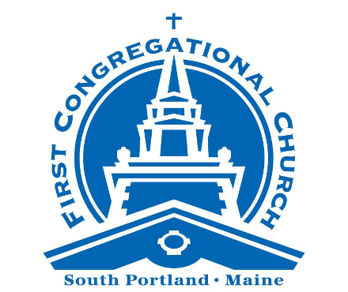

Sunday Worship
August 17, 2025

We are a progressive community of faith seeking to follow
the teachings of Jesus, pursue justice and live God’s love.

No matter who you are, or where you are on life’s journey,
you are welcome here.



A Note for Families / Folks of All Ages: We worship all together this morning. There are clipboards with paper and coloring pages at the back of the sanctuary, for worshippers of any age to use during the service.

PRELUDE Precious Lord, Take My Hand Dorsey
Viva L'Ouverture, Alto
WELCOME TO WORSHIP Rev. Stephen Savage
*CALL TO WORSHIP
One: Come all you who thirst for more, who hunger for what satisfies the soul.
Come all who seek the rich flavor of life, and the abundance of God’s love.
Come not with coin or compensation, but with open hands and open hearts, for the gifts of God are freely given to all who seek them.

ALL: Let us praise the God of the feast, with words and songs and deeds! Amen

*OPENING HYMN Come Thou Fount Of Every Blessing #407

PRAYER FOR FORGIVENESS*

One: God of abundance, you have promised to provide us with more than

mere survival; in seeking to satisfy our deepest hungers, we shall find an even more profound sustenance than human imagination could envision. In your holy love, you have given us so much: talents and treasure in unlimited supply. But often, we spend these on superficial needs. We throw away our plenty on little hungers and petty desires. We seek the fleeting delight of novelty, of prettiness, and of veneer. We follow the urges to momentary importance; to the notice of a fickle society more interested in noise and sparkle than in mundane sturdiness. We chase after happiness while neglecting joy; we chase after romance while neglecting love; we skim the surface while fearing the depths.
God of grace, we are hungry. God of mercy, quench our thirst.
ALL: Forgive us, we pray, for our fearfulness, as we rely more upon our
own human illusions of control and satisfaction, even though we know that these illusions separate us from you. Forgive us for not trusting in your grace, in your abundance, in the covenant promises that you have renewed with every generation. In Christ, may we learn to love you more than we love ourselves. Amen.
____________________________________________
*Please rise, on your feet or in your hearts.
PRAYERFUL PAUSE

WORDS OF ASSURANCE

*PASSING OF THE PEACE

One: The peace of Christ be with you.
All: And also with you.

*SUNG RESPONSE Halle, Halle, Halle! Caribbean Traditional
Halle, halle, halle-lu-lu-jah! [3 times]
Hal-le-lu-jah, hal-le-lu-jah!

TIME FOR ALL GOD’S CHILDREN

PRAYER OF ILLUMINATION Debbie Grew

One: This is the sacred story of God’s journey with God’s people.
All: Holy One, open our ears to hear, our hearts to receive
and our lives to be expanded by your Word. Amen.

SCRIPTURE READING Isaiah 55: 1-3

1 “Come, all you who are thirsty,
come to the waters;
and you who have no money,
come, buy and eat!
Come, buy wine and milk
without money and without cost.
2 Why spend money on what is not bread,
and your labor on what does not satisfy?
Listen, listen to me, and eat what is good,
and you will delight in the richest of fare.
3 Give ear and come to me;
listen, that you may live.
I will make an everlasting covenant with you,
my faithful love promised to David.

SERMON A Supper That Satisfies Rev. Stephen Savage

MOMENT OF CONTEMPLATIVE SILENCE

ANTHEM His Eye is On the Sparrow Martin and Gabriel
Viva L'Ouverture, Alto

PASTORAL PRAYER

The Lord’s Prayer

Our Father-Mother in heaven, hallowed be Thy name. Thy kin-dom come; Thy will be done on earth as it is in heaven. Give us this day our daily bread and forgive us our debts as we forgive our debtors. And lead us not into temptation but deliver us from evil, for thine is the kin-dom and the power and the glory forever. Amen.

SUNG RESPONSE Hear Our Prayer, O God Whelpton

Hear our prayer, O God. Hear our prayer, O God.
Incline your ear to us and grant us your peace.


OFFERING INVITATION

Help us to live God’s love and justice. You can make a secure gift by using the QR code, going to fccucc.org/donate, or by adding your contribution to the box at the back of the sanctuary. Thank you!

CLOSING HYMN God of Grace and God of Laughter #32

ANNOUNCEMENTS

BENEDICTION

POSTLUDE O Happy Day Doddridge and Hawkins
Viva L'Ouverture, Alto

* * * * * * *
Join us for lemonade on the front porch after worship.

WORSHIP NOTES
Thank you to this morning’s ushers: Team E, Rich Armstrong captain.
The flowers on the altar are in loving memory of Suzanne Rideout and Karen, Phillip, and Raymond Durrell from Debbie and Jim Rideout,
Livestream: Thank you to Alex Ratta for managing our worship livestream, this week and every week!
*Today’s prayer for forgiveness was written by Eliza Buchakjian-Tweedy, Pastor at First Church Congregational, Rochester, NH.

WEEKLY @ FCC UCC

Tuesday Bible Study meets from 12:30 - 1:30 pm in Davidson Lounge: whether you are a member of FCC UCC or you are simply interested in joining in the fun, you are invited to join our weekly bible study group, to enjoy fellowship and to discuss the worship and focal scripture from the past Sunday. All are welcome!
Meetinghouse Choir, Handbells and Handchimes are on summer recess. Rehearsals will resume on August 27.

MISSION CORNER

Volunteer for Preble Street Food Hub: On the last Friday of each month, we prepare meals at the Food Hub, 75 Darling Avenue, South Portland, for delivery to Preble Street satellite sites. Please join us! To learn more about how to volunteer, see the Weekly
Word or contact Danna Wiggins at dannawig2@gmail.com

Clynk Bags are available in the narthex (inside main entrance). Fill with returnable bottles and cans and return it to a Clynk collection site near Hannaford to support FCC!

BUILDING UPDATES!

Small Parking Lot: The small church parking lot adjoining Mitchell Road is about to be repaved. The town is also scheduled to repave Mitchell Road this summer. Stay tuned for updates.

THE WIDER COMMUNITY

Community Sing, TODAY, August 17, and every other Sunday, 3:30 pm (2:45pm for anyone looking to get organized around singing at demonstrations and public events): A bi-weekly gathering to find hope in singing together. Sign up to learn about future events or to opt-in to the Response Team to sing at resistance and change events:
- To register or ask questions, email Emilia Dahlin at: emilia@emiliadahlin.com

Ideal Maine Band, Tuesdays at 6 pm, Ocean Gateway: Sing along with the Ideal Maine Band during their weekly rehearsals. It's joyous and raucous! Come for the music, the camaraderie, and the community singing. And if you're up for it, get ready to sing at upcoming protests. https://www.idealmaineband.org/

A DAILY BLESSING: Need a spirit-lift? Sign up to receive a daily blessing in your inbox, each morning between now and September 15. Offered as part of the Bless Project at South Congregational Church, UCC, in Kennebunkport.

Sign up here:
https://www.southchurchucc.org/blessproject#daily-blessing

WHAT’S UP?

Want to stay in the loop? Make sure you are on our email list! To UPDATE or ADD your contact info, go to: fccucc.org and select “Contact Us” then select “Contact Info Update Form.”

Also, look for us on Facebook: facebook.com/fccucc
on Instagram: instagram.com/fccucc_s.portland
and on our YouTube channel: youtube.com/@FCCUCCSouthPortland




Doodles, Notes and Reflections…



Help Love and Justice to Flourish
Make a Summertime Gift!
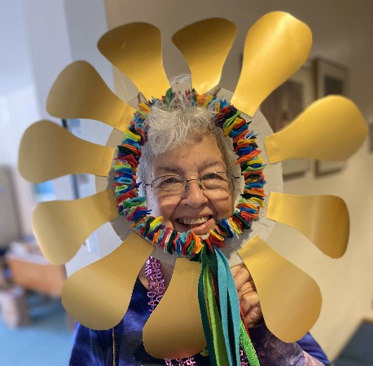
In January, our congregation approved an
aspirational budget, because we want ministries
that spread God's love and justice to flourish.

We need your help to make that happen.

Gifts and pledges we have received to date
won’t cover all our 2025 costs.

Join our flash appeal to raise $20,000 by August 15!
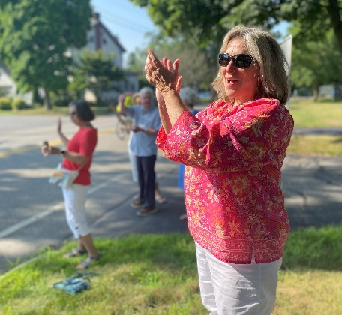
Why? When you invest in this community of faith,
you help us to:
Gather Community Nourish Spirits
Make Music Pursue Justice
Care for Vulnerable Neighbors
Declare God’s Extravagant Love
Equip, Bless and Cheer Each Other On!
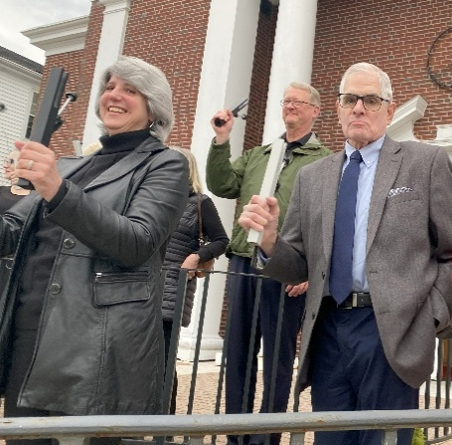
Please make a new or additional gift today. Go to:
fccucc.org/donate (‘Summer Appeal” in memo)
OR
Mail your donation to:
First Congregational Church, UCC
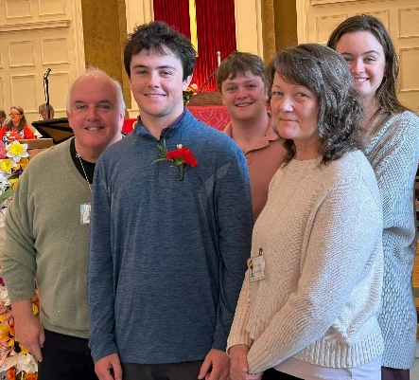
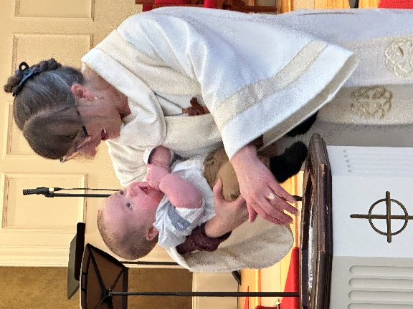
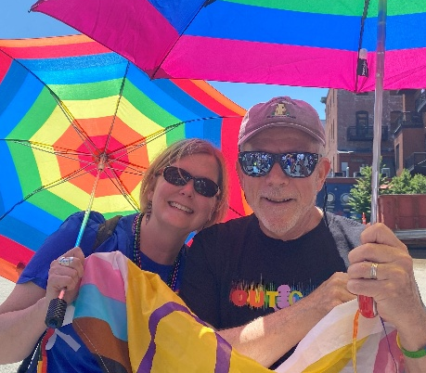
301 Cottage Road, South Portland, ME 04106

